**12 aug 2020**

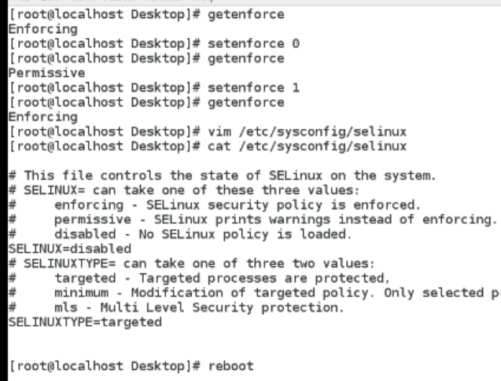

**Changed from enforcing to disabled now reboot**

**Getenforce 🡺 disabled**

**Setenforce 1 🡺 setenforce :selinux is disabled error @ so change to enforcing using**

**vim /etc/sysconfig/selinux & reboot & check getenforce 🡺 enforcing**

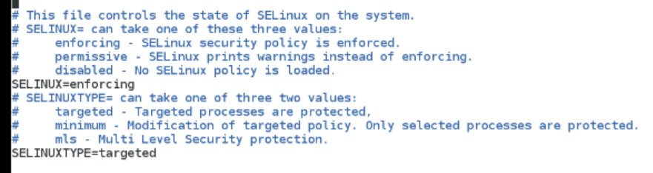

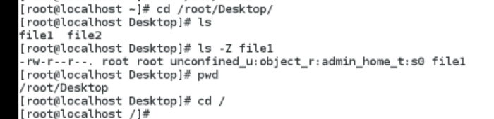

**Checking context for / dire**

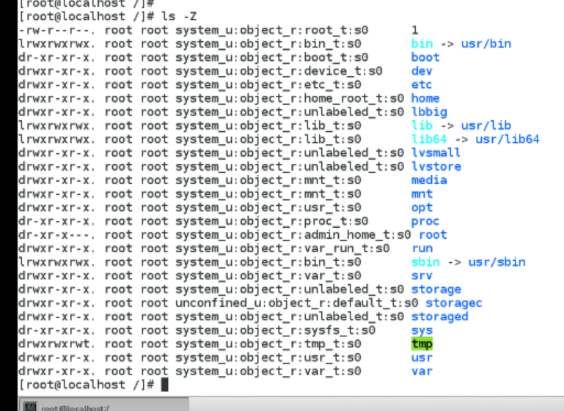

**Creatinf files and checking ther context how it is created**

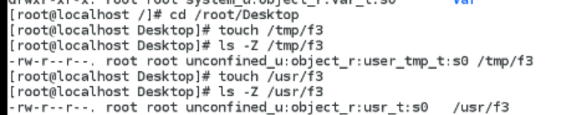

**To change context enforcing & restoring context**

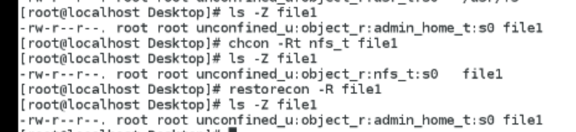

**To check all other**

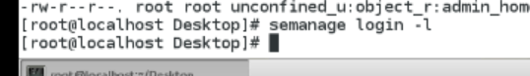

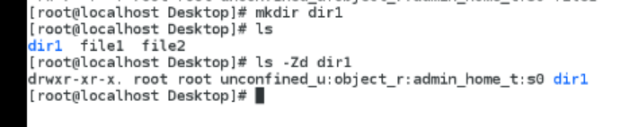

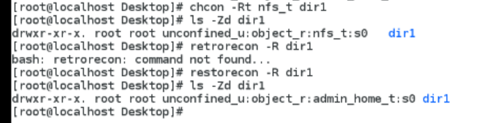

**Boolean**

**Sir history**

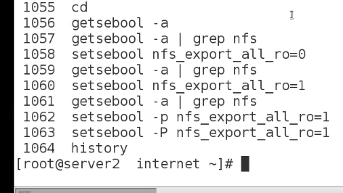

**Lab**

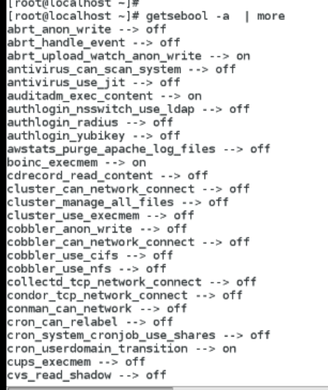



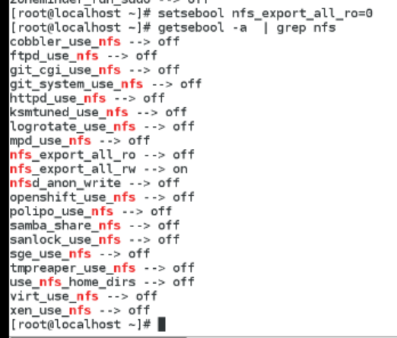

**Initially off …..try to on….& check**

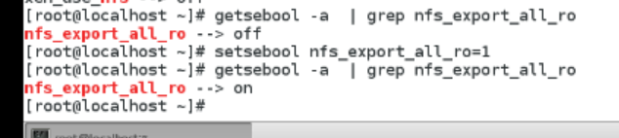

**To save persistently use command setsebool – P nfs_export_all_ro**

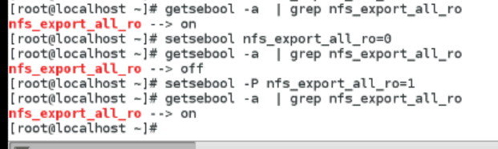

**Afternoon -ftp**

**Installing vsftpd …installed…goto cd /var/ftp/pub & copy somefiles to this from desktop**

**& check & restart vsftpd**

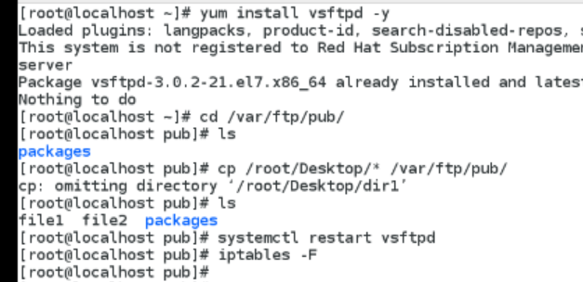

**Check ip adress**

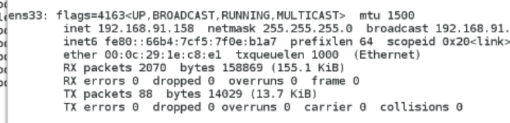

**Goto client vm….try to ping server machine & try to connect “ftp ipadress”**

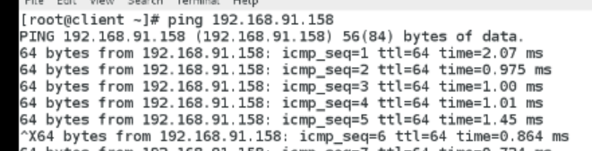

**If ftp connected ok……..if not connected then install ftp …for that change directory**

**cd /run/media/root/Rhel & install ftp by “rpm –ivh ftp.0”**

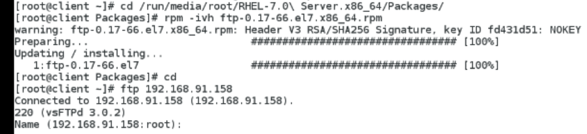

**Now connect ftp……give name=ftp… passwd= nothing @enter..suessfully login…!!**

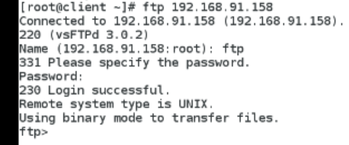

**Check files …only pub will be there…..goto PUB**

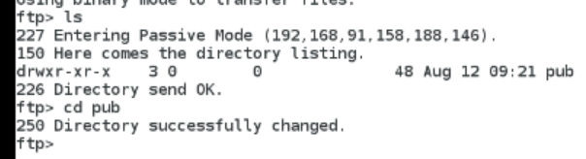

**List**

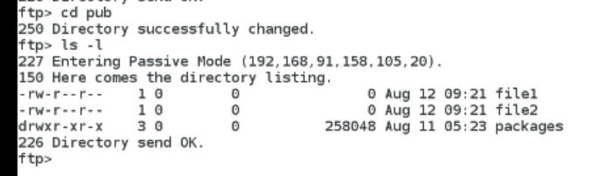

**Come out ..use BYE**

**List wt in client…now want to download file1**

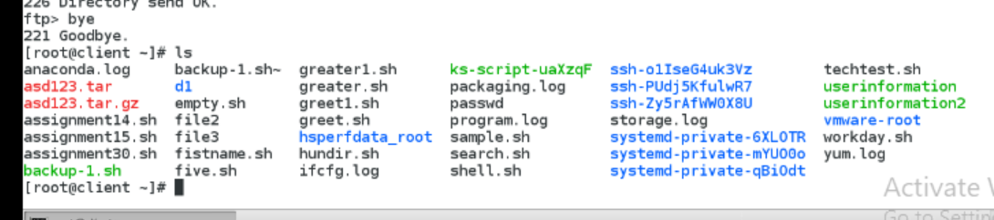

**Connect ti ftp by ftp serveripadress**

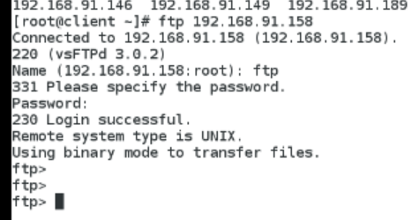

**Change to pub**



**list**

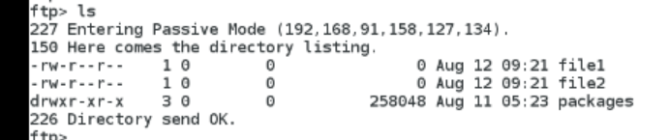

**Download file1 by “get file1”…..downloaded file successfully….& now trying to upload a file file3**

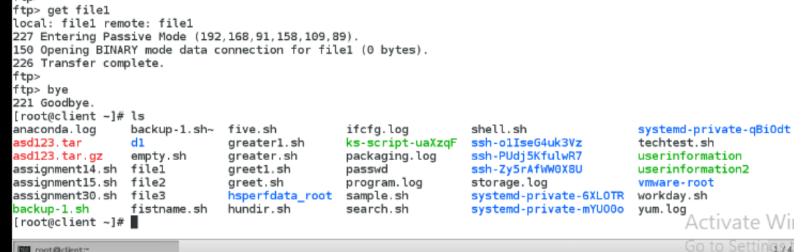

**Connect to ftp….cd to pub ….try to upload by “put file3 ”..cant permission denined so……**

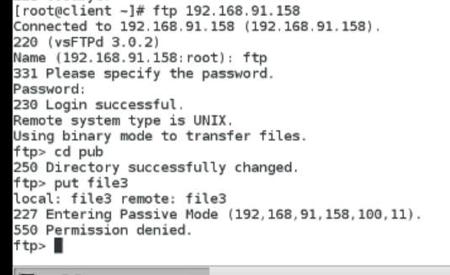

**So goto Server …check enforce( enforcing )**

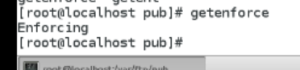

**Goto vsftpd.conf file & permit / uncomment 1)anon_upload_enable=yes 2) anon_mkdir_write_enable=yes**



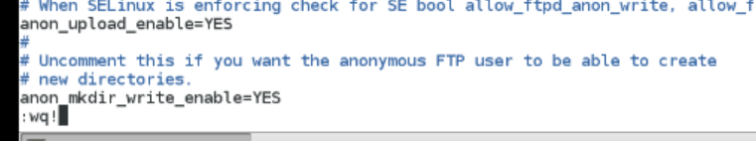

**Change to var/ftp/….make direc upload ….add permissions 777to upload directoy …restart vsftpd**

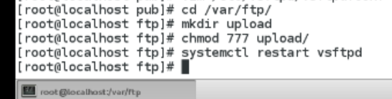

**Goto client ….login as ftp user …list files..goto upload directory**

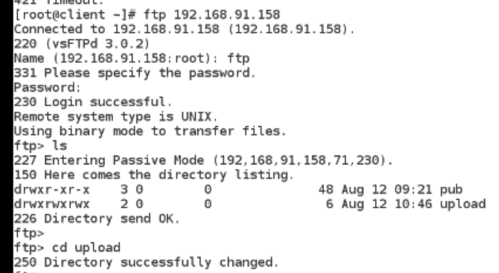

**Now upload by “put file3”…..here we cannot create file @error ………..so**

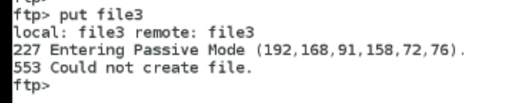

**Goto server = change selinux mode into** “permissive”

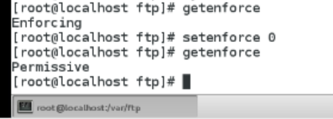

**Goto client …. Try to upload file the transfer is complete… but for enforcing its not success..here selinux is adding role**

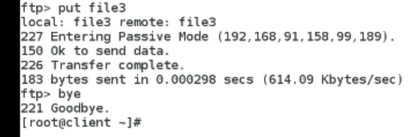

**Goto server … now change to enforcing mode**

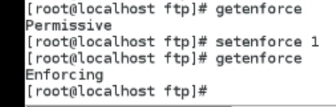

**Check Boolean & make enable**

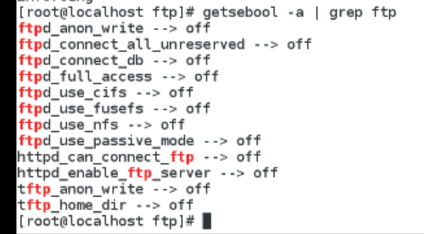

1. **Ftpd_anon_write=1**
2. **Ftpd_full_access=1**

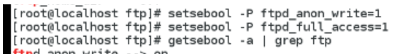

**Confirm wheher it on or not …now**

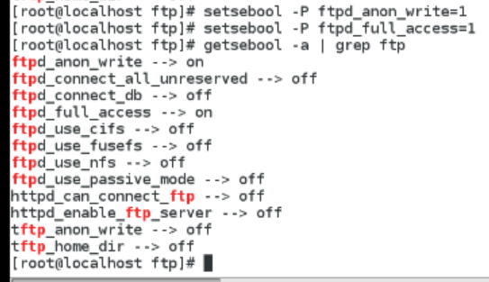

**Goto client … login as ftp …cd to upload& upload file five.sh…sucess**

